30. Develop a system using UML for the Train ticket Reservation System.

Activity daigram:

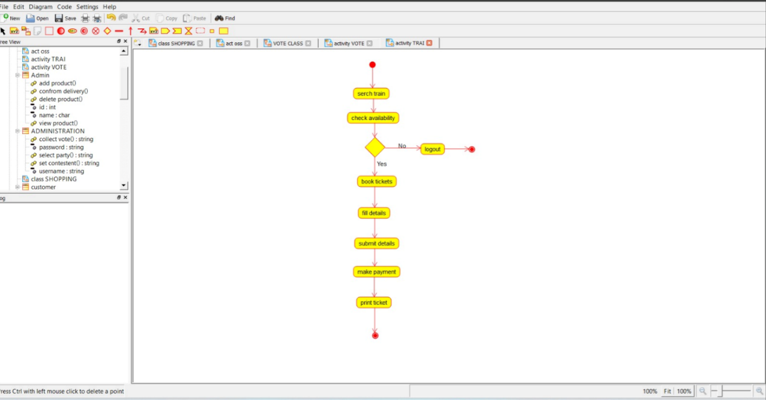

Class diagram:

